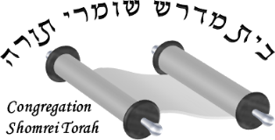

Congregation Shomrei Torah

1360 Clifton Ave. #908

Clifton, NJ 07012

Placeholder